Products from Mica

Apart from this, there are various other uses of this mineral such as marker dials for navigation compasses, stove and kerosene heater windows, oxygen-breathing equipment, optical filters, thermal regulators, pyrometers, micathermic heater elements, and radiation aperture covers for microwave ovens.

**Natural mica:** -

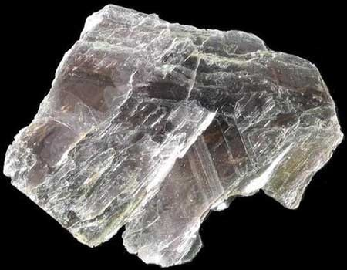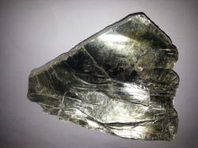

Thickness – 2m.

Tensile strength – 8x4.

Form – powder.

Product description: - Every type of rubber, plastic, ebonite, Bakelite, PVC, Acrylic, Nylon, Teflon, fiber glass sheets, Rods, tubes, Heat shrink tubing (2:1), all kinds of electrical and insulation goods.

**Fabricated mica:** - The term fabricated mica is used for denoting the process of cutting, punching and stamping of natural sheet mica. This product is extensively used in the electrical and electronic industries all over the world.

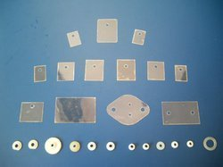

**Mica washer:** - Mica Washer is widely used for electrical and electronic applications in different industries as thermal and electrical insulation. It comes with circular punched and stamped natural mica parts with round openings in the center. This unique shape makes it a perfect.

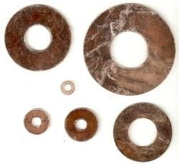

**Mica insulator:** - Mica Insulators are made using accurately punched mica parts according to specific shapes and dimension. Mica Insulators are widely used as increasing washers and trusted as consistent insulators in power transistors, IC’s, diodes, heat sinks, rectifiers and various other semiconductor.

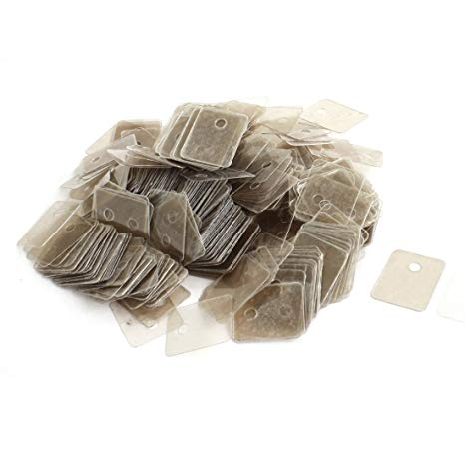

**Window mica:** - Due to its high lucidity, flatness and thermal fortitude, Mica is used as viewing windows for kerosene stoves, petro ax lamps, wood stoves, furnaces and fireplaces. This gives high safety and security to the professionals working in the danger zones and ensures avoidance of any accidents.

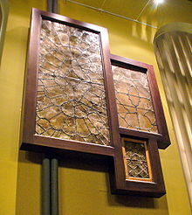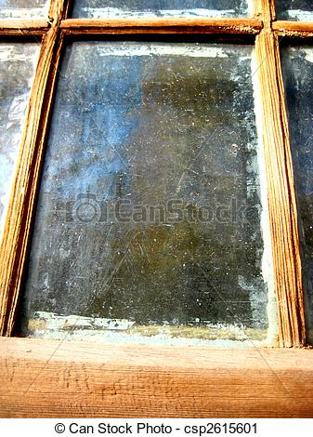

**Corrugated mica:** - Corrugated or Crimped Mica is equipped by passing through a specifically designed rolling machine. It is delivered to the clients in its best form of perpendicularly corrugated ribs. This product finds its application in wrapping the soldering iron electrodes. It plays an imperative role to abolish physical contact between the resistance wire and copper bit guaranteeing dependable service life.

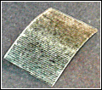

**Wrapper mica:** - Mica Wrapper also known as Wrapper Mica finds its shape when it is rolled or wrapped into tube form that is eventually placed over the soldering iron electrodes. It plays a very important role to remove physical contact amid the resistance wire and copper bit ensuring trustworthy service life.

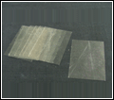

**Mica discs:** - Mica Disc provides the excellent protection to circular viewport glasses and provides ideal visibility for checking the amount of combustion and liquid level in high-pressure steam boilers. It is also widely used in breathing apparatus, fuses, communication devices, broadband wave plates for optical instruments, Geiger counters, etc.

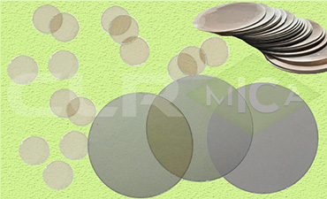

**Mica spacers:** - Mica in the form of bridges or spacers is used in radio and television vacuum tubes. These Mica Spacers serve to grip the tube elements in position, insulated from each other and at consistent distances.

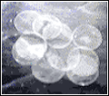

**Mica shields:** - C. L. Roontgen is counted as one of the most distinguished manufacturer and exporter of premium range of MICA SHIELDS. These mica shields are prepared by some of the most experienced people in processing Mica and are cut by hand, machined.

